Objetive:

the Application objective is facilitating the routine of Office 365 administrators, assigning licenses in large quantities, using a CSV file or an existing distribution group, set location, plans and product to be assigned to users in Office 365, without the need to know in Powershell.

Resources:

* Application protected by public digital certificate
* Add, Replace and Remove Licensing
* Generate a Report of active users
* Assign licenses to users in Office 365 through distribution group or a CSV file
* Find all available plans and products in the tenant
* Shows the friendly names of plans and products
* Show the number of available licenses of the selected plan
* Disable or enable any specific product within the selected plan
* allows you to choose the location to be configured on the user
* Generates detailed logs of licensed users and users who had some error in the license allocation
* 2 idioms English and portuguese

**Pre – requirements**

**Always Run the Tool as Administrator**

**Operational system:**

* Windows 8.1
* Windows 10

PS. all other requirements are automatically installed

* Microsoft online services sign-in assistant
* Azure Active Directory Module

**How to use**

Install the MSI file

Click in start > All programs> and  open Office 365 license Tool

Remember you need to have network access to Office 365 Servers

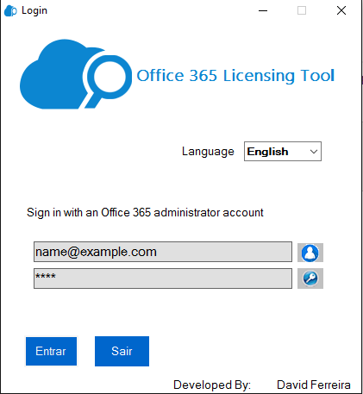

ps You should login with Office 365 Global admin user

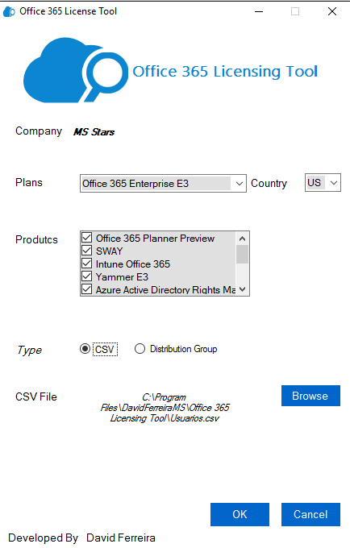

CSV file should have the pattern below

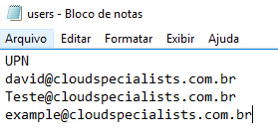

Click in OK and wait the process to finish

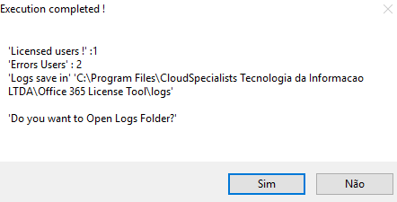

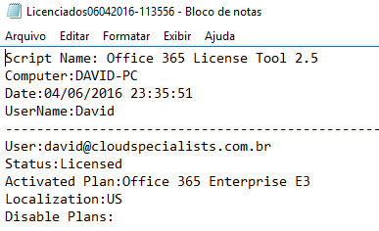

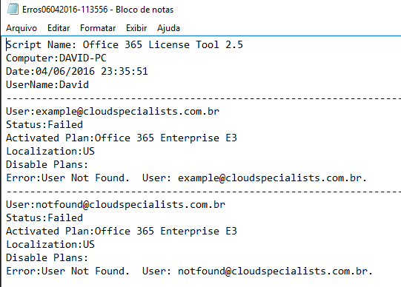

If you have any question or bug please send a E-mail to me [davidferreira21@hotmail.com](mailto:davidferreira21@hotmail.com)

I hope I have been helpful

thanks